# Screenshots for installing Ubuntu 20.04 Desktop as a VMware Virtual Machine (VM)

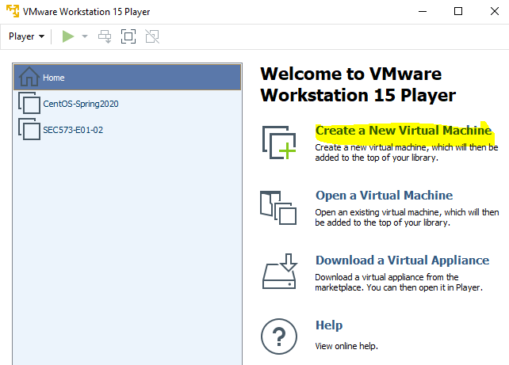  
Use the Browse… button to tell Workstation Player where the ISO file lives.

**Note**: When Workstation Player recognizes the OS it is about to install, it will offer you the choice to use “Easy Install.” This allows you to pre-enter the data the installation will need, such as computer name, user name, keyboard type, etc. It will then enter those items for you when the OS installs, which speeds the installation process. If you want to see the questions the OS asks during installation and answer them yourself, select “I will install the operating system later.” You will have to connect the VM to the installation ISO manually, and then the installation will proceed just as it does on fresh hardware.

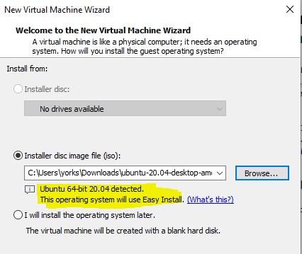

If you choose not to do the ‘Easy Install’, scroll down in this document to the section, “Note: If you elected not to use Easy Install, or,Installing Ubuntu the hard way.”

Continuing with the Easy Install.

Linux usernames must be lower case letters. Do not forget your password!!

You can use a simple password here unless you plan to store secrets on the VM.

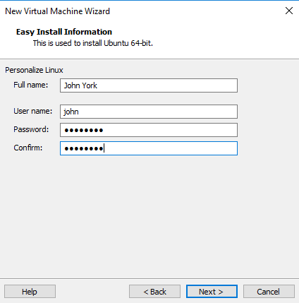

The standard location is C:\Users\[your user name]\Documents\Virtual Machines, which is fine. Give the VM any name you like, within reason.

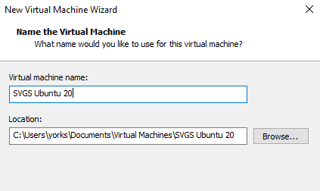

The defaults here, 20 GB disk size and split the virtual disk into multiple files, should be fine.

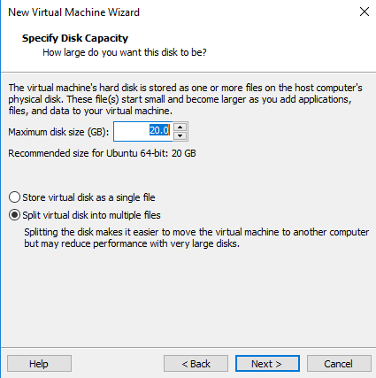

Your VM will run better if you give it 2 CPUs and 4 GB of RAM (assuming your physical machine has 8 GB of RAM or more.) Select customize Hardware.  
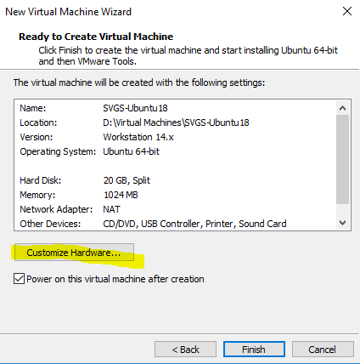

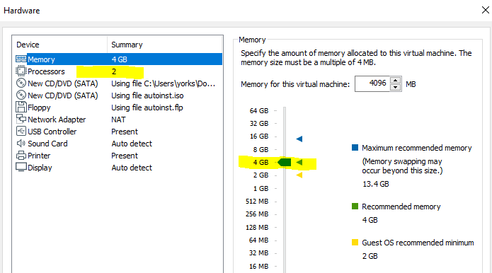

Close the hardware window, click Finish, and the installation will proceed on its own. You should eventually see an Ubuntu login screen.

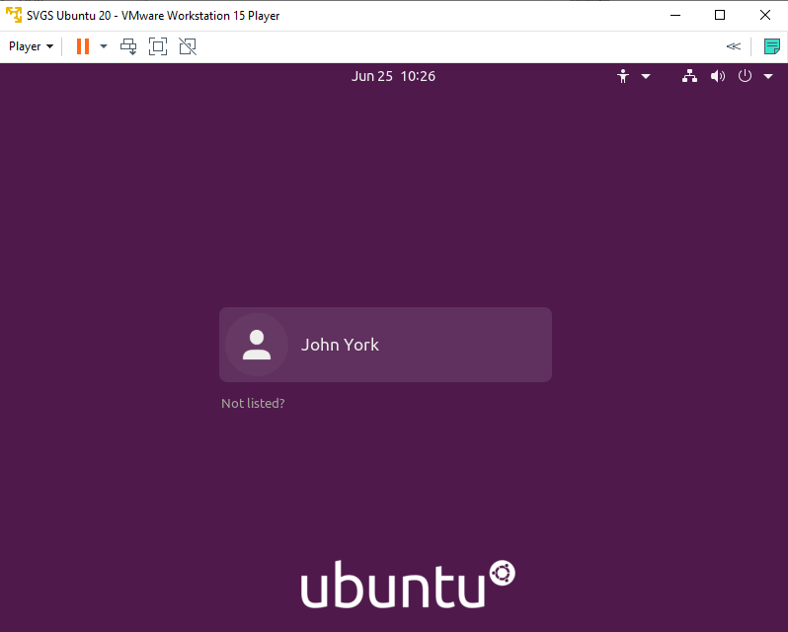

# Note: If you elected not to use Easy Install, or, Installing Ubuntu the hard way

After selecting Create a New Virtual Machine, this shows what happens when I will install the operating system later is selected.  
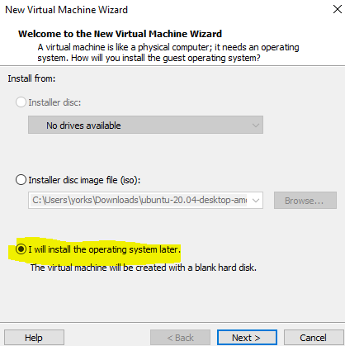

We can still let VMware Player know that we plan to install Linux, Ubunt 64-bit.  
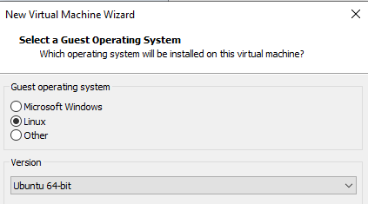

Name the virtual machine and give it a place to live.  
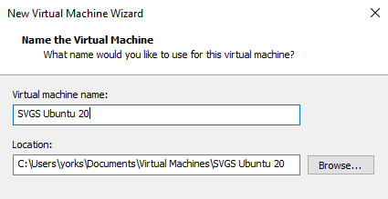

The disk capacity can be left at the defaults.  
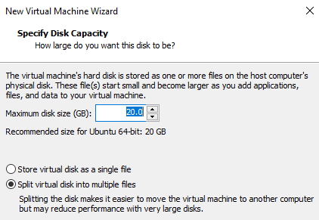

If the VM has not been allocated 2 CPPU cores and 4 GB of RAM, you can select Customize Hardware to change that.  
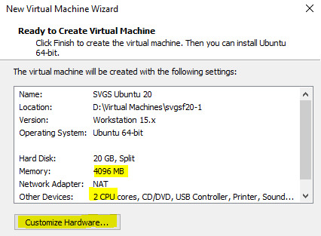

If you click Play virtual machine without telling it where to find the installation ISO, you will find the VM fails to boot because it cannot find media.  
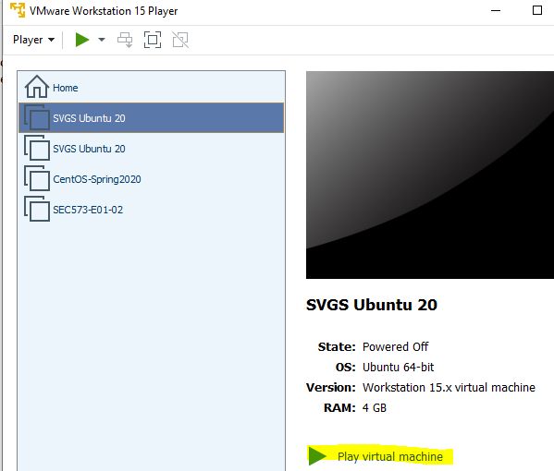

Note: This is normal, just say no.  
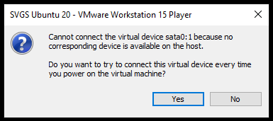

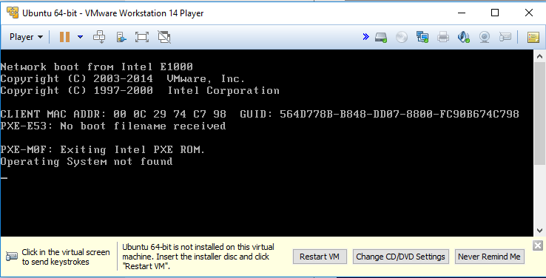

We could have avoided this error by selecting Change virtual machine settings instead of Play virtual machine, but it is good to see this error anyway. Fix the error by using the VM settings to tell the VM to boot from the installation ISO. You can click on “Change CD/DVD Settings.”

Be sure the Device status is Connected and Connect at power on. Use the browse button to find the ISO file you wish to install. Note: If the selections you want are grayed out, shut down the VM, open Player again, and select Edit virtual machine settings.

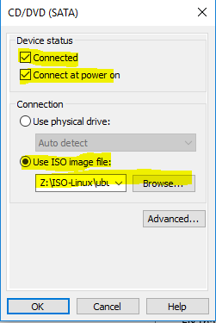

**Or**, you can select Player > Removable Devices > CD/DVD > Connect

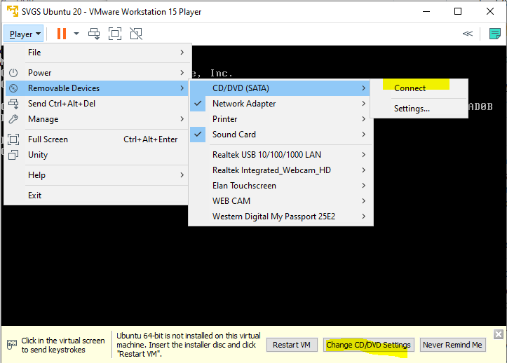

Then make the same settings as before.

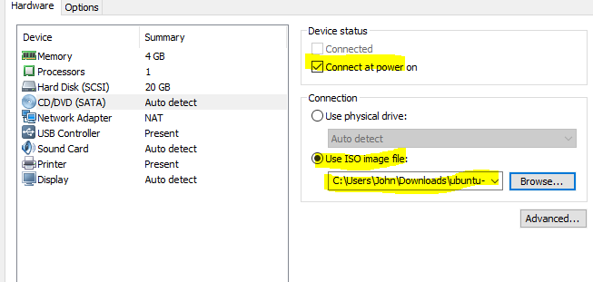

When the VM boots, it should start the installation process from the ISO file. If you select “Try Ubuntu”, the VM will boot entirely from the CD (or ISO), will always require the CD/ISO to boot, and changes you make will be lost any time the VM restarts. This is called a “Live CD” installation” and has the advantage of taking very little disc space.

We will install our VM on the files in the VM folder so that we do not need the ISO to boot (after the installation) and any changes we make will be retained between reboots. Select Install Ubuntu.

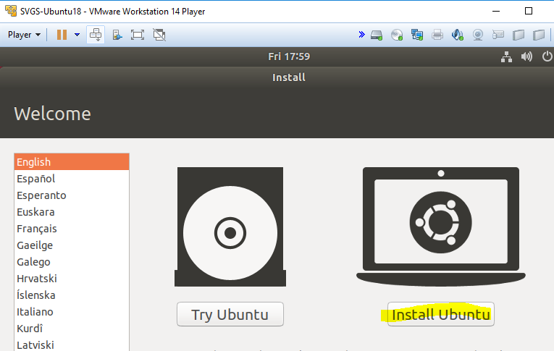

I selected the standard US English keyboard.

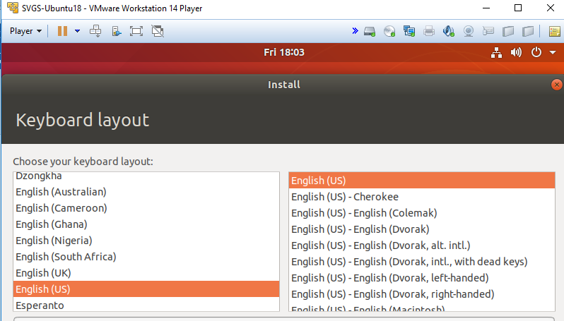

The Normal installation has a lot of software we will not use, but it does include most of what we need. Later on, you can make a VM with the Minimal installation if you like.  
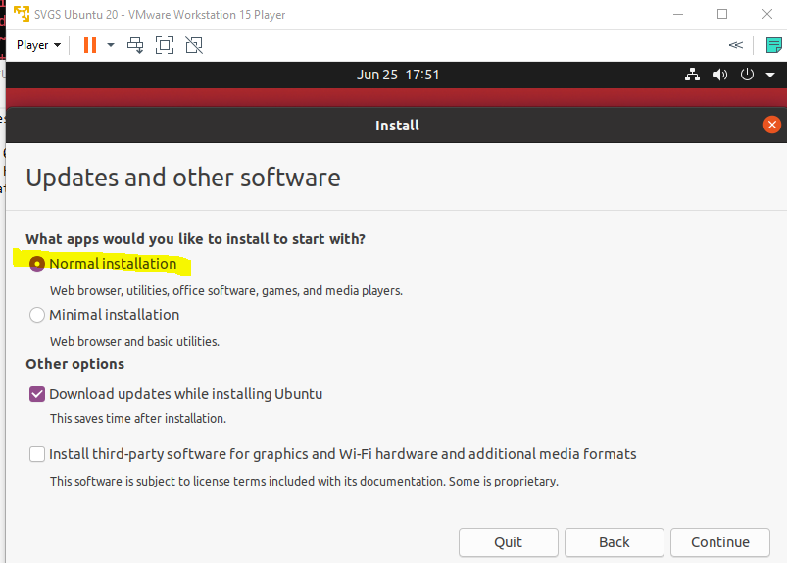

If we were installing on hardware, we would want to ensure that there is nothing important on the hard disk, as it will be overwritten. On a VM, the “hard disc” is just a file that has not been created yet so there is no danger of losing data. 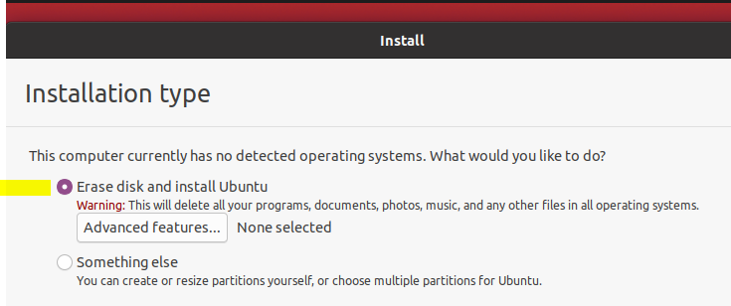

You will need to click Continue on the next screen, and then set the time zone.

Note that Linux requires the username to be in lower case. We will not store sensitive data on this VM, but we will be entering the password a lot; you can use a short password if you like. Be sure to remember your password!

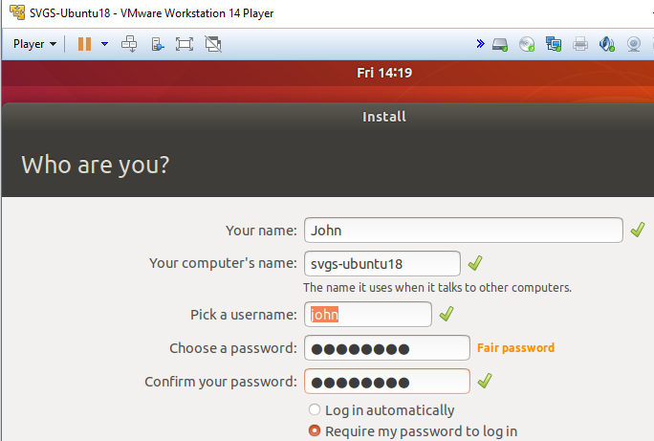

Done! (Almost)

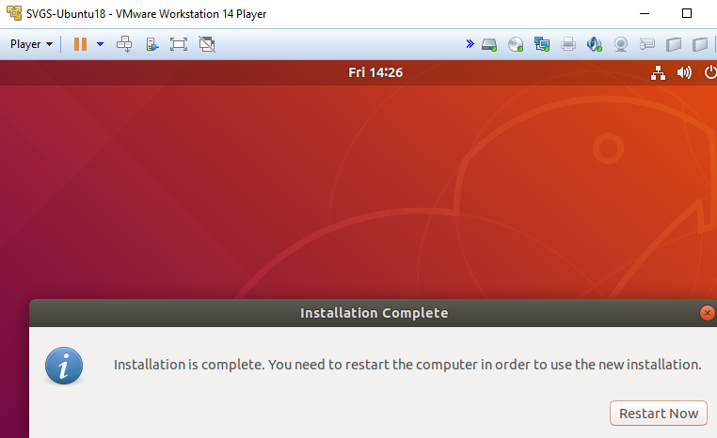

We don’t want to boot from the CD/ISO anymore, so disconnect it.

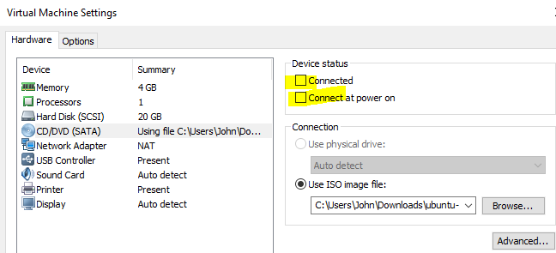

# Installing VMware Tools

VMware tools provide better drivers and software to make the OS easier to use in a VM environment. VMware Workstation Player comes with tools for several OSs, but… Let me show you the problem--**read, but don’t click for a moment**.

You can access the VMware version of the tools through the Player > Manage menu.

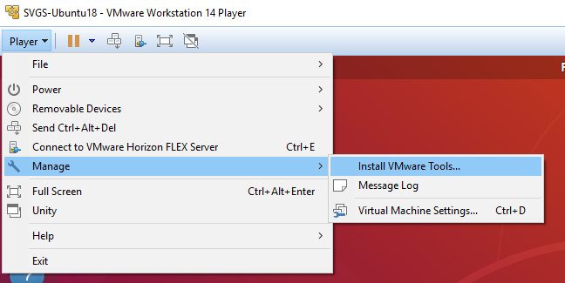

All it does is mount an ISO as a CDROM on your desktop. Right-click properties shows the folder the file lives in.

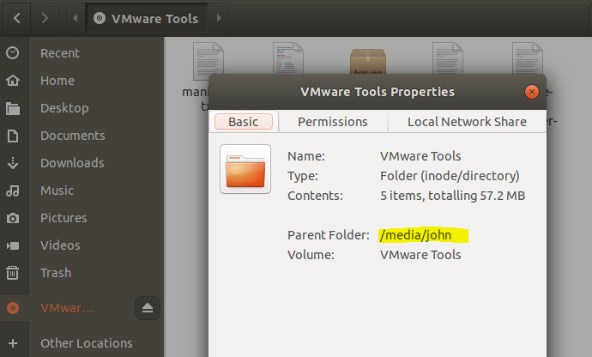

After going through a bunch of commands to copy it, unzip it, and run it, it tells you it does not recommend using the VMware tools that came with Player. Instead, you should use the open-vm-tools that comes with the Ubuntu distribution. Ugh.

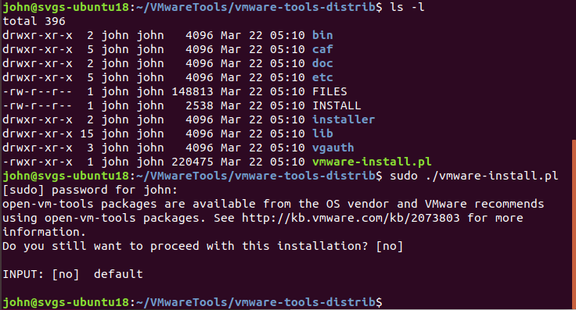

**OK, now you can click, type, whatever**.

So, now we’ll skip ahead and install open-vm-tools from the command line, very quickly. The command is:  
sudo apt-get install open-vm-tools

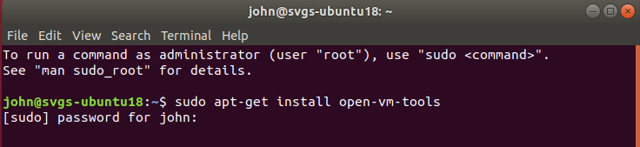

Once you put in your password and tell it to install, it will be done in moments.

Note: You may find that Ubuntu has detected that you have installed it as a VM, and installed open-vm-tools already. No problem.